**Lab Report: 1**



**Digital System Design Lab**

**Spring 2023**

**Submitted by:**

**Hamid Ur Rehman 20 Pwcse1969**

**Semester: 6**

“On my honor, as a student of University of Engineering and Technology Peshawar, I have neither nor received unauthorized assistance on this academic work”

**Submitted to:**

**Eng:Muhammad Usman**

**Introduction to MODELSIM And Gate Level Modeling**

# Objective

Objectives of this lab are:

* To get familiar Modelsim
* To know about gate level modeling

## MODELSIM

MODELSIM is a simulator which can be used for the simulations of both VHDL and Verilog HDL. It has the following interface.

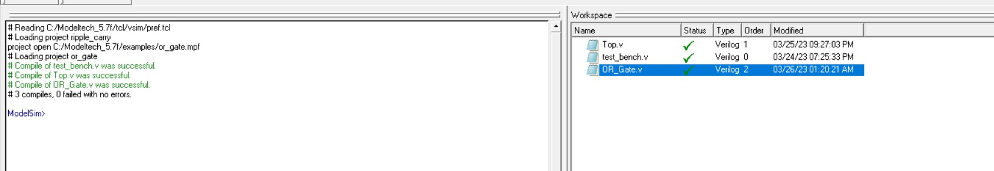

1. Implementation of OR Gate in MODELSIM

# Code

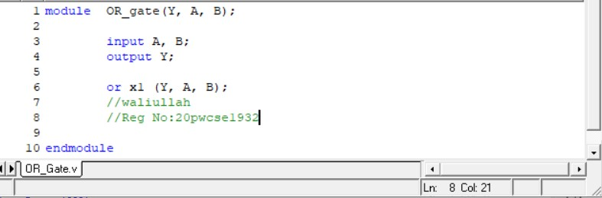

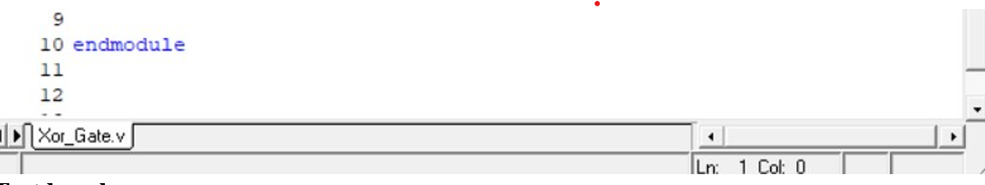

# Test bench

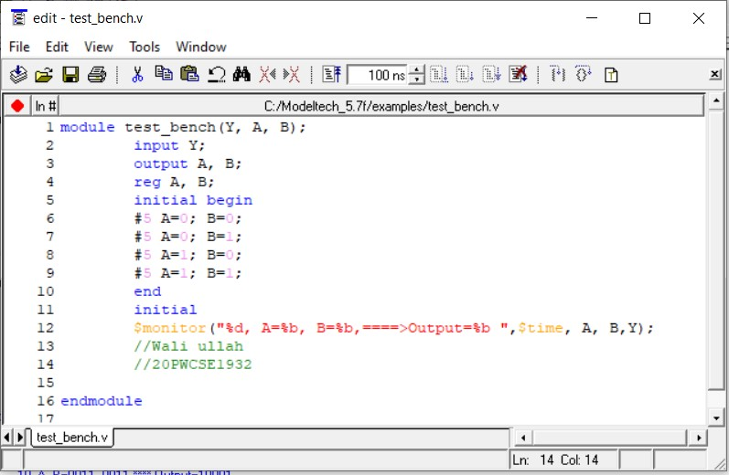

**Simulation Top:**

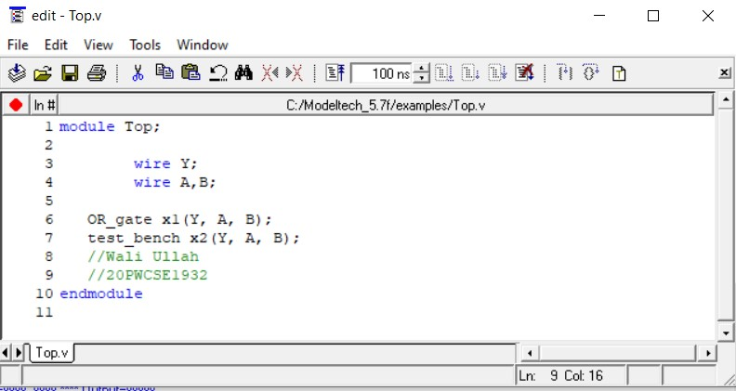



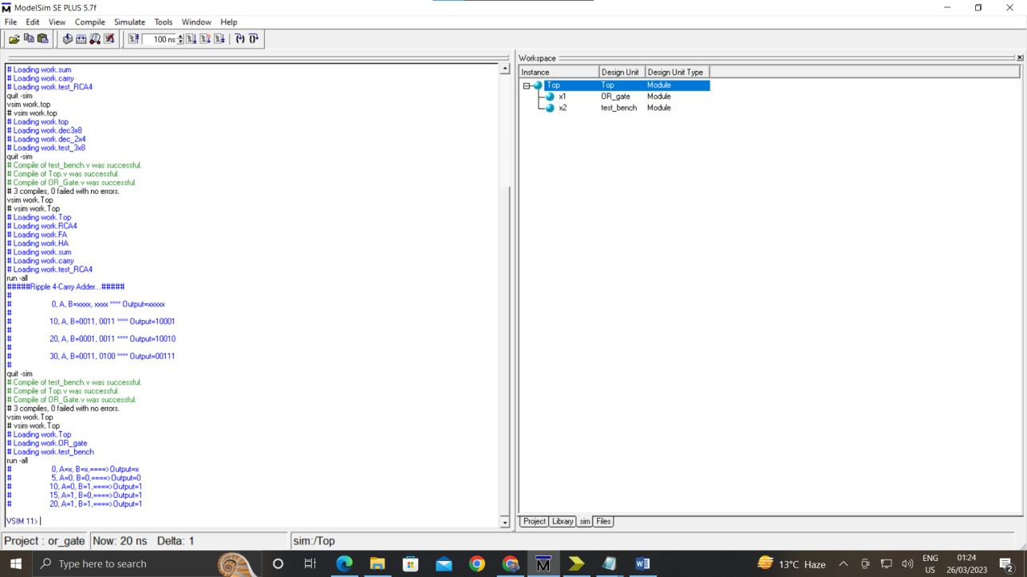

## Wave

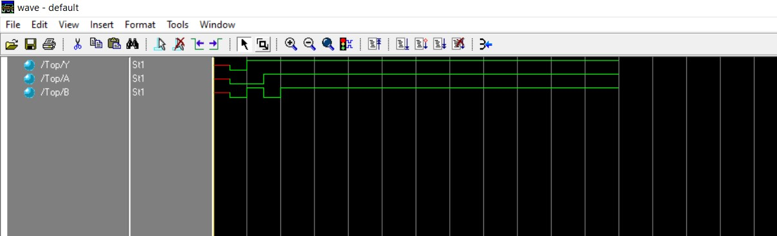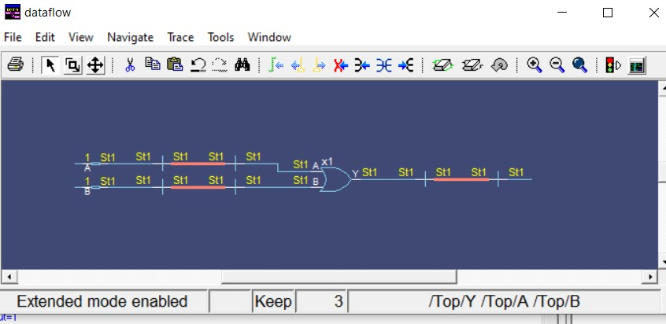

2. Implementation of And Gate in MODELSIM

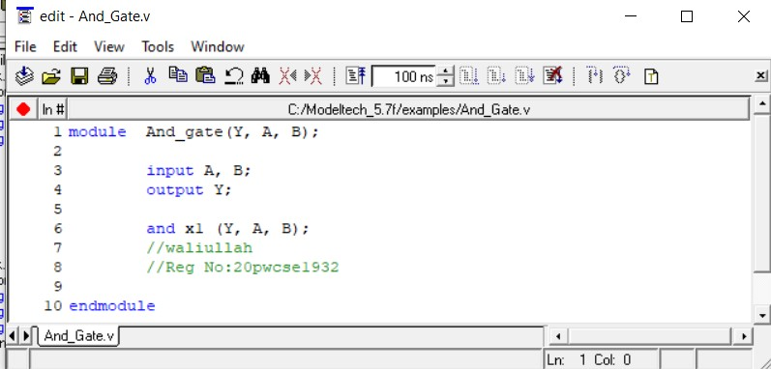



**Testbench:**

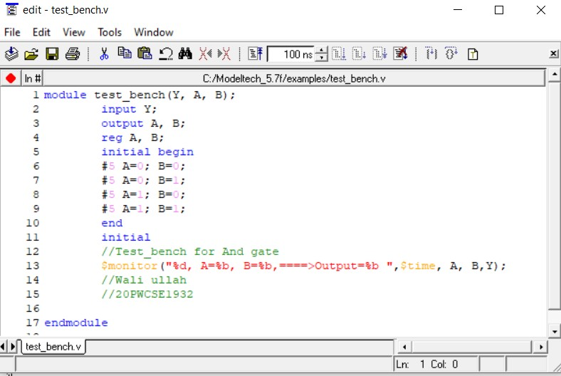

**Simulation Top:**

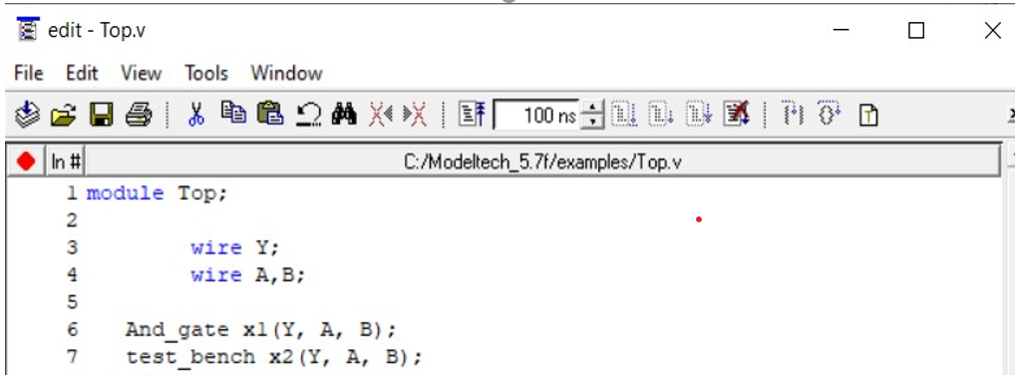

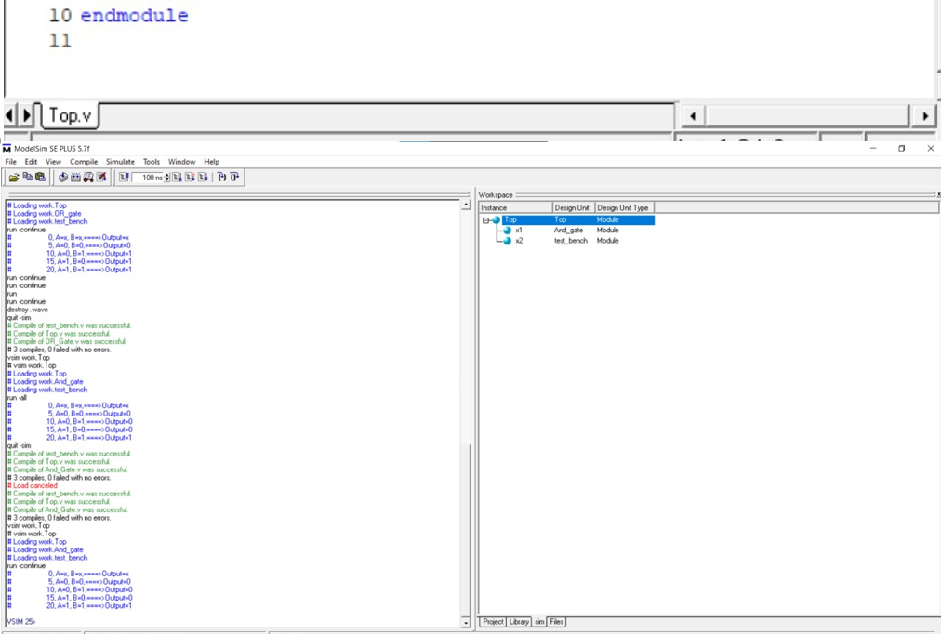

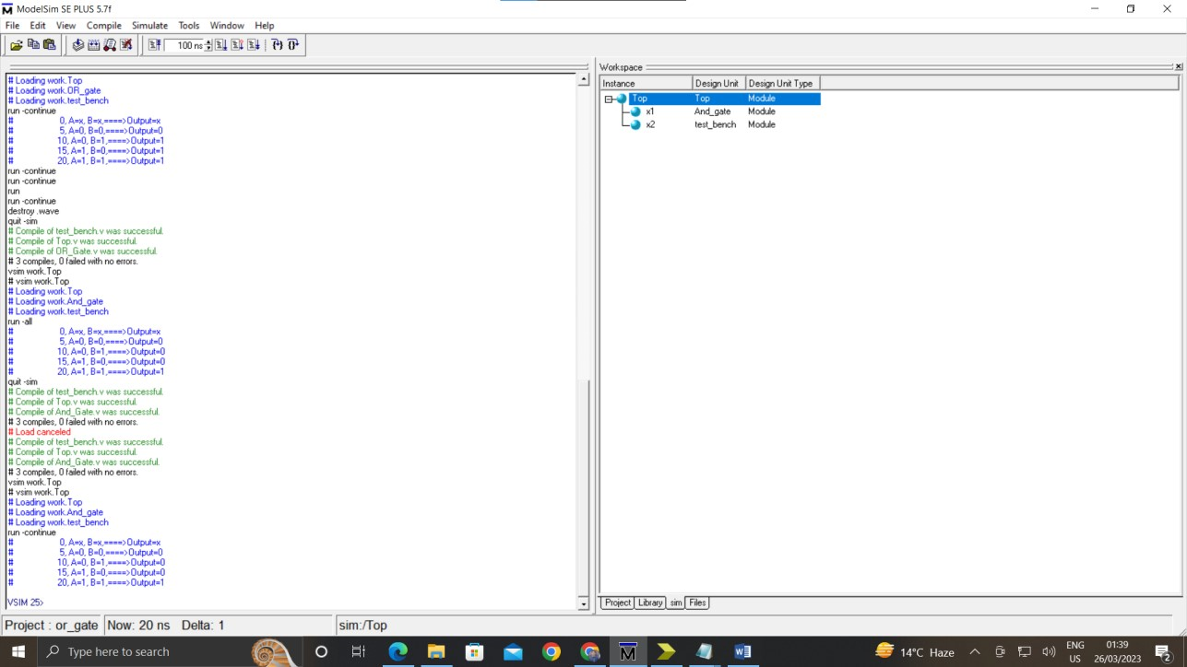

## Data Flow

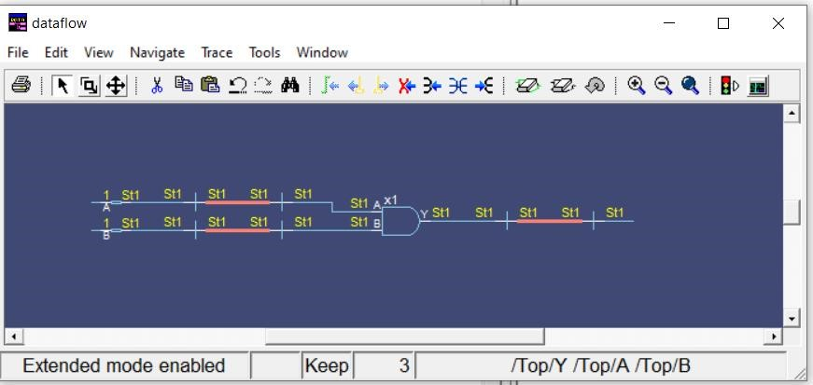

3. Implementation of XOR Gate in MODELSIM

## Code

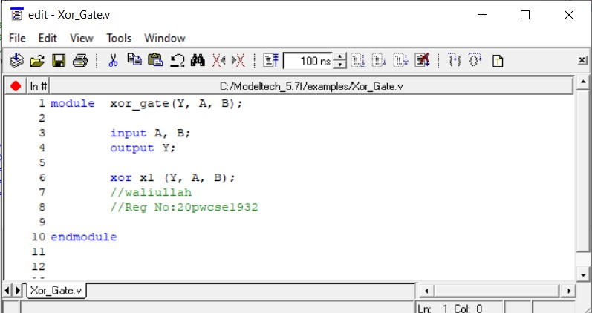



**Test bench**

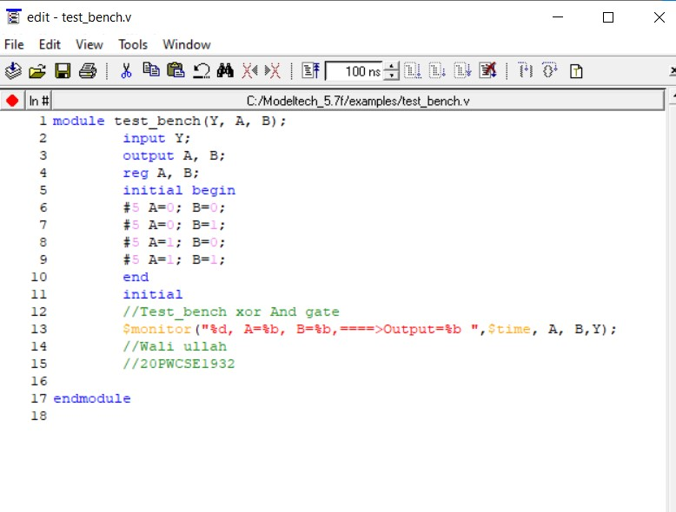



**Top**:

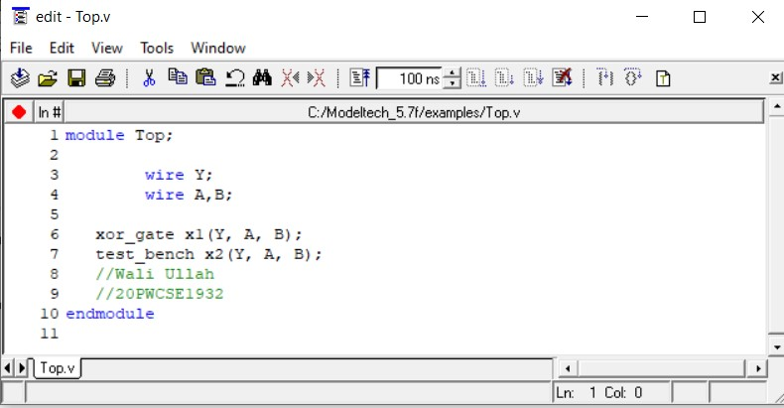



# Simulation

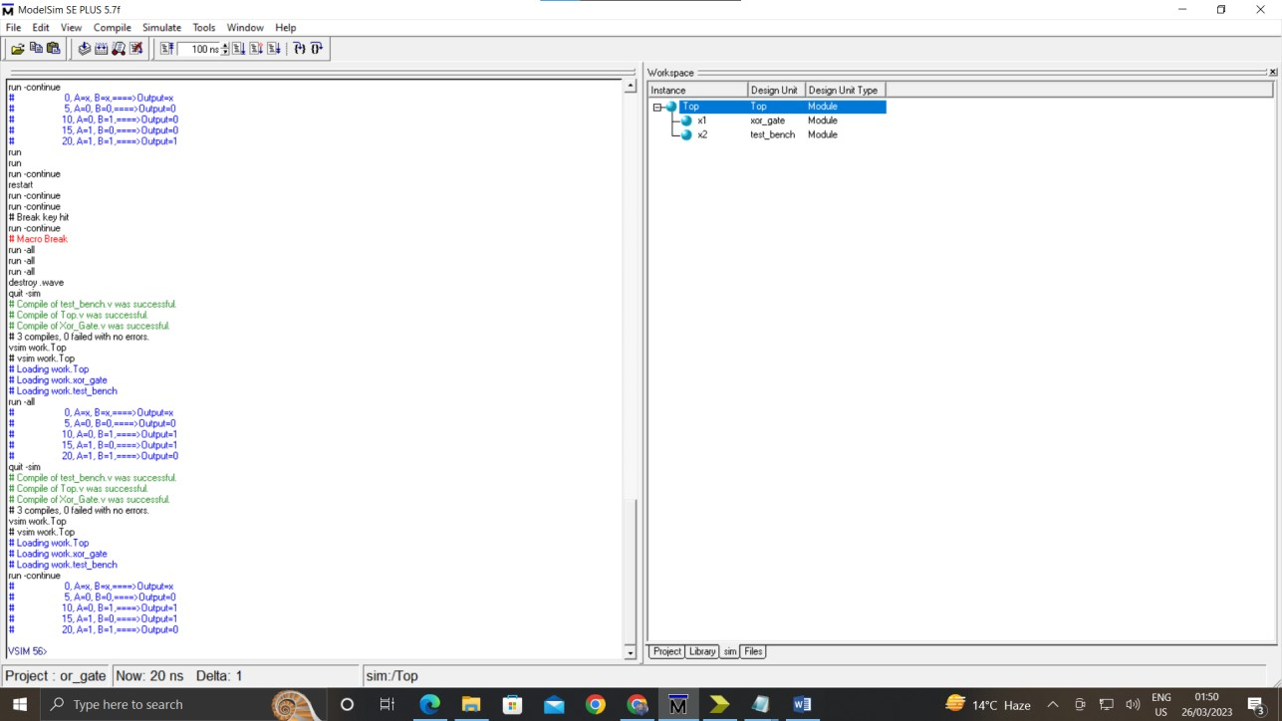

## Wave

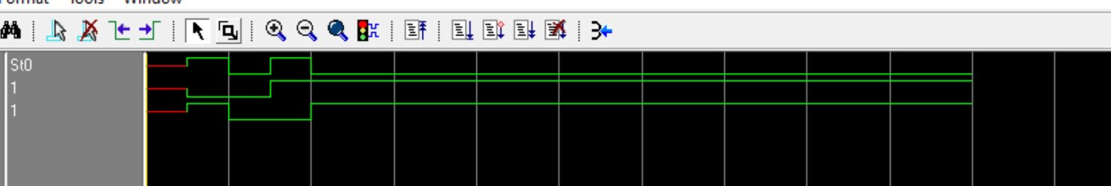

## Data Flow

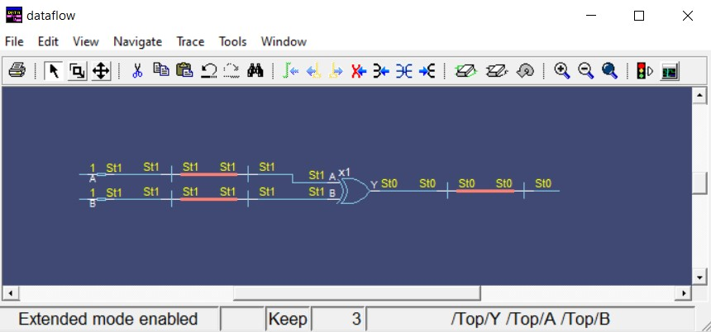

4. Implementation of Full Adder Using Two Half Adders in MODELSIM **Sum:**

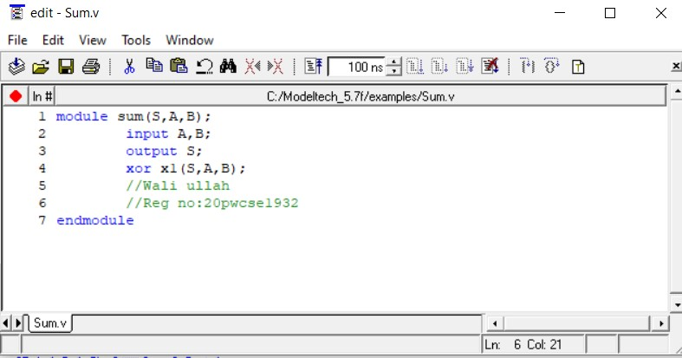



# Carry

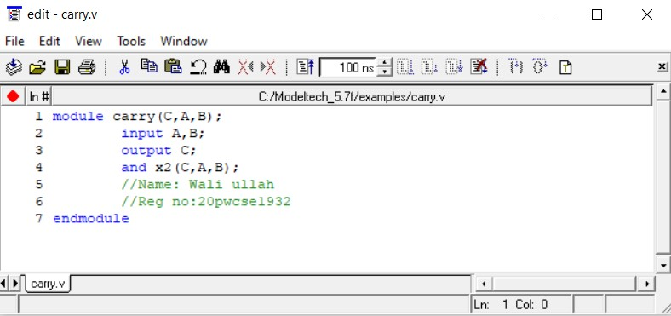



# Half Adder

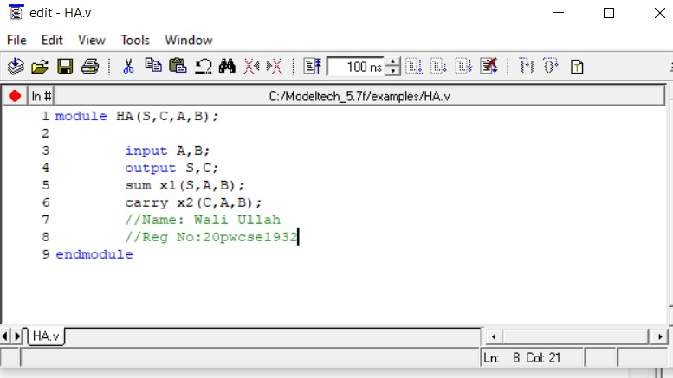



# Full Adder

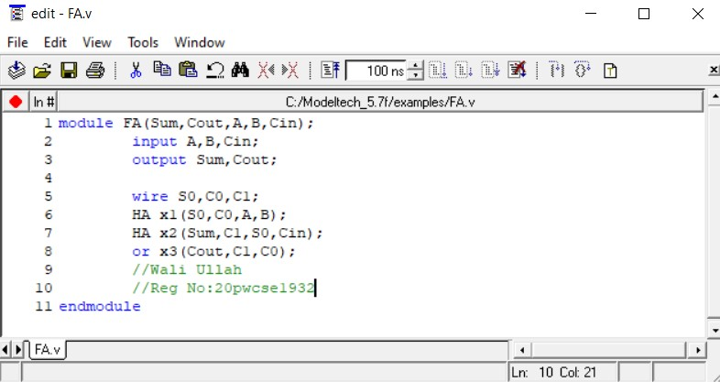



# Test bench

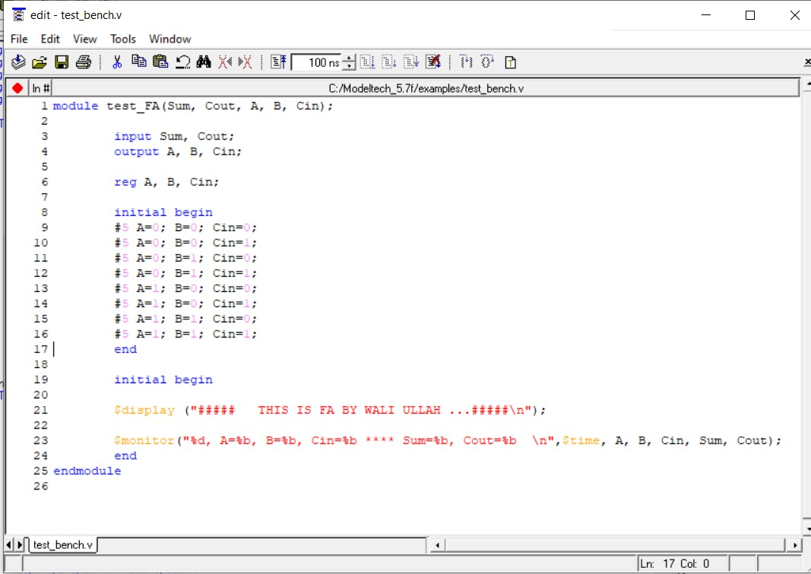

# Top

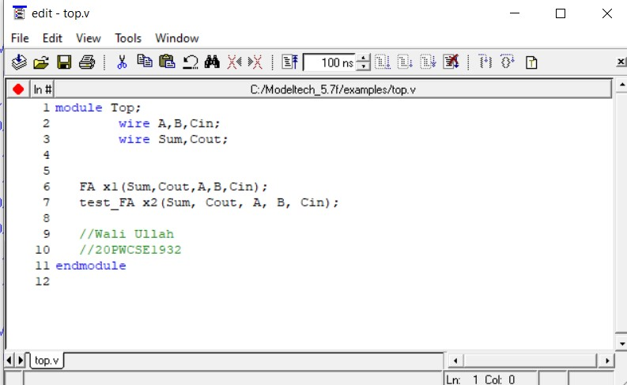



# Simulation

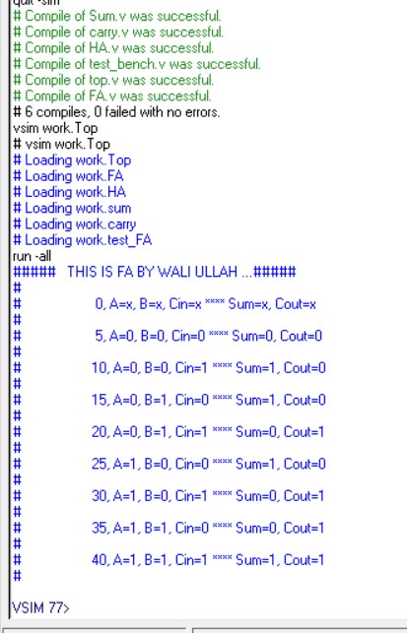

# Data Flow

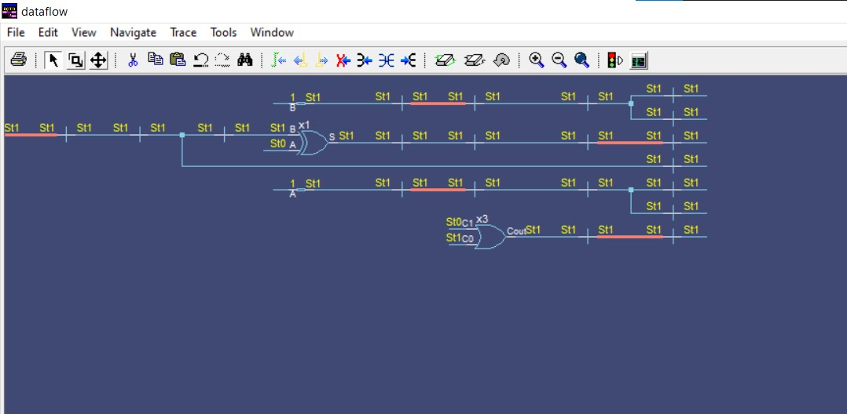

**Wave:**

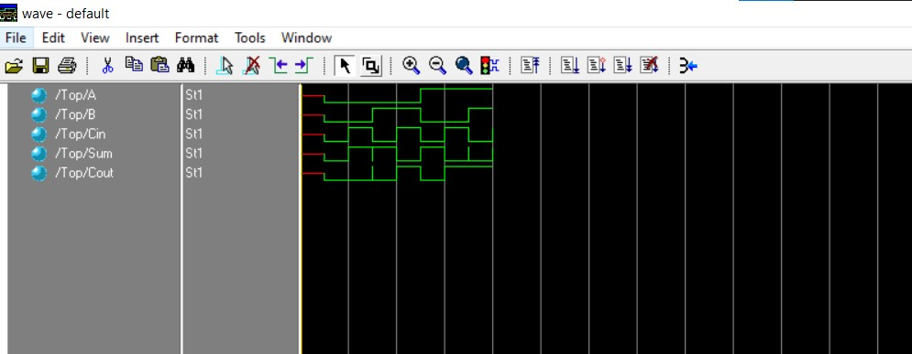

5. Implement a buffer at the gate level.

## Code

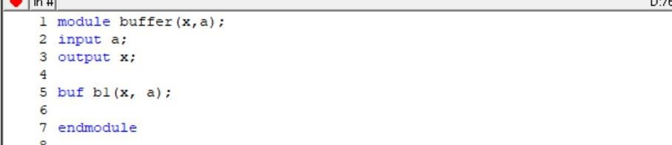

## Test bench

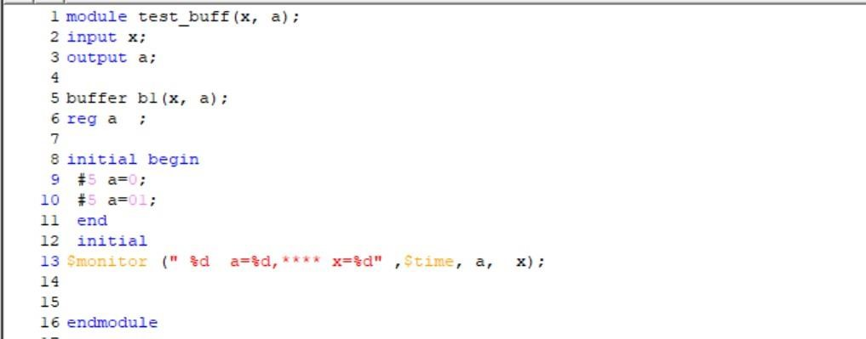

## Output

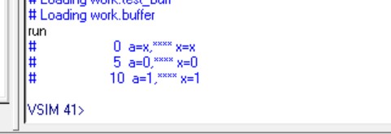

# Wave

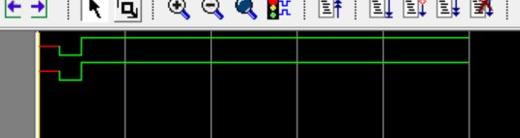

# Dataflow

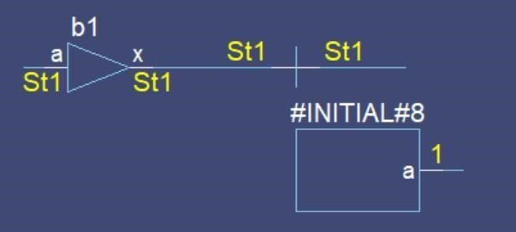

6. Implement an inverter at the gate level.

## Code

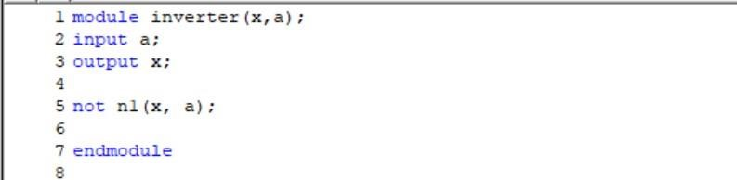

## Test bench

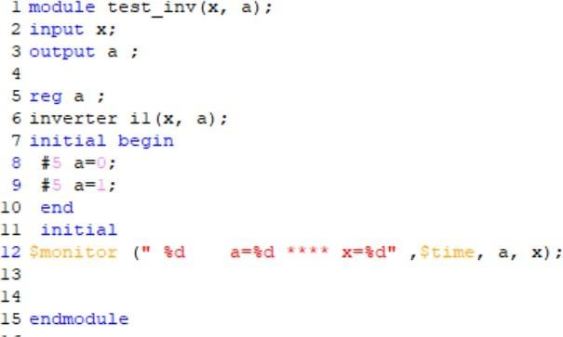

## Output

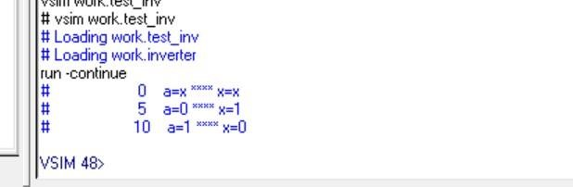

## Wave

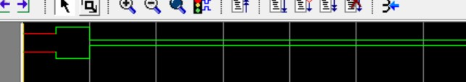

## Dataflow

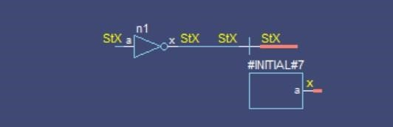

7. Implement an OR gate using a NAND gates.

## Code

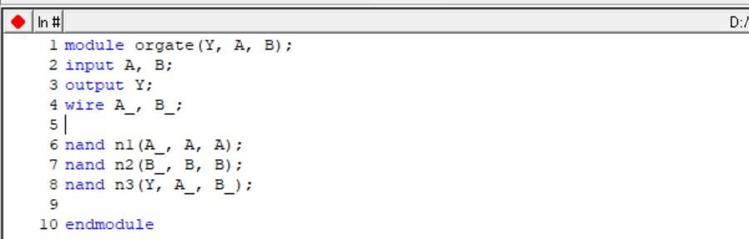

## Test bench

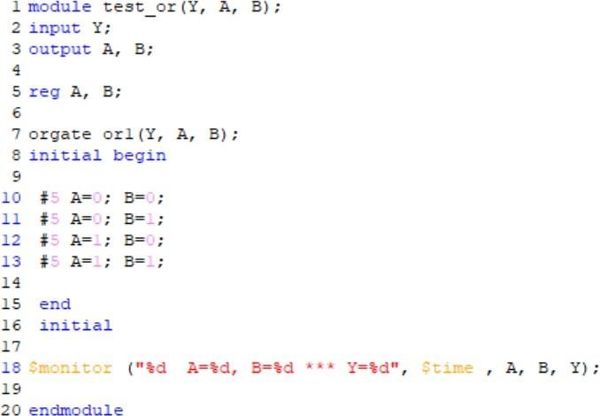

## Output

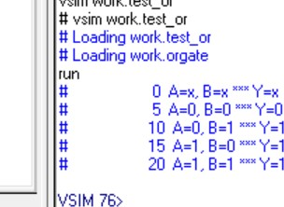

## Wave

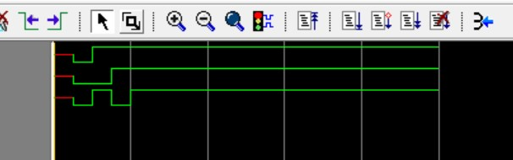

## Dataflow

8. Implement the following equation where z is output and x1, x2, x3, x4, and x5 are inputs of the circuit. z = ( y1 + y2 )’ y1 = x1.x2

y2 = (x3.x4.x5)’

## Code

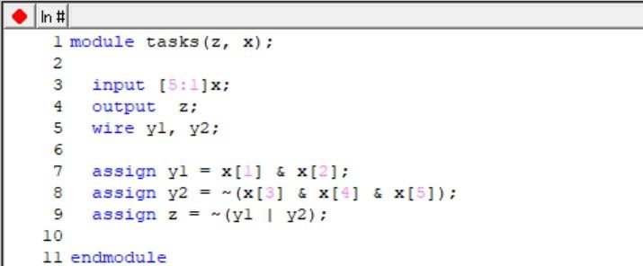

## Test bench

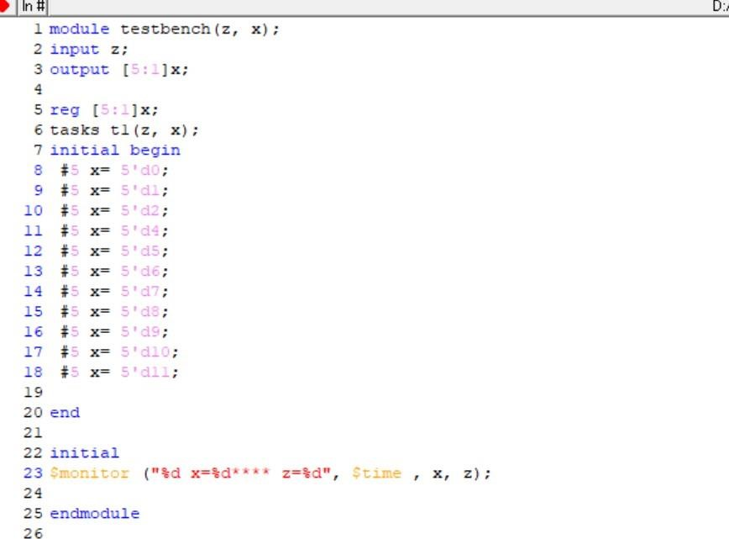

## Output

